Part A
Aim:
(1) K means.
(2) Back propagation

Prerequisite: Python, Jupyter IDE and Internet connection

K-means:

Introduction:
Recall the first property of clusters – it states that the points within a cluster should be similar to each other. So, our aim here is to minimize the distance between the points within a cluster.
There is an algorithm that tries to minimize the distance of the points in a cluster with their centroid – the k-means clustering technique.
K-means is a centroid-based algorithm, or a distance-based algorithm, where we calculate the distances to assign a point to a cluster. In K-Means, each cluster is associated with a centroid.
The main objective of the K-Means algorithm is to minimize the sum of distances between the points and their respective cluster centroid.
Let’s now take an example to understand how K-Means actually works:
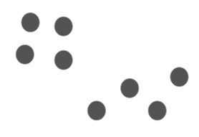
We have these 8 points and we want to apply k-means to create clusters for these points. Here’s how we can do it.

Step 1: Choose the number of clusters k
The first step in k-means is to pick the number of clusters, k.

Step 2: Select k random points from the data as centroids
Next, we randomly select the centroid for each cluster. Let’s say we want to have 2 clusters, so k is equal to 2 here. We then randomly select the centroid:
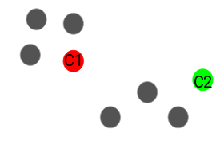
Here, the red and green circles represent the centroid for these clusters.

Step 3: Assign all the points to the closest cluster centroid
Once we have initialized the centroids, we assign each point to the closest cluster centroid:
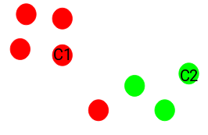
Here you can see that the points which are closer to the red point are assigned to the red cluster whereas the points which are closer to the green point are assigned to the green cluster.

Step 4: Recompute the centroids of newly formed clusters
Now, once we have assigned all of the points to either cluster, the next step is to compute the centroids of newly formed clusters:
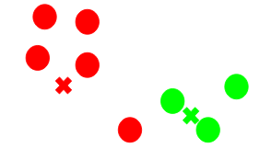
Here, the red and green crosses are the new centroids.

Step 5: Repeat steps 3 and 4
We then repeat steps 3 and 4:
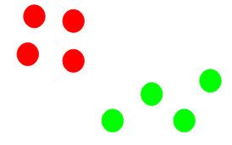
The step of computing the centroid and assigning all the points to the cluster based on their distance from the centroid is a single iteration. But wait – when should we stop this process? It can’t run till eternity, right?

Stopping Criteria for K-Means Clustering
There are essentially three stopping criteria that can be adopted to stop the K-means algorithm:
- Centroids of newly formed clusters do not change
- Points remain in the same cluster
- Maximum number of iterations are reached

Back propagation

Introduction:
We start with the network's random performance estimation. Instead, we compare the neural network's predicted performance with real efficiency. We then change our weight and damage so that our expected performance is close to the true performance that is commonly called "neuronal network readiness."

Step 1: Cost calculation. In the back propagation segment the first step is to determine the "Effect."

The estimate costs can simply be determined by calculating the discrepancy between the forecast performance and actual production. This is the gap so the cost is very high. There are several methods to measure the damage, but using the loss function used Medium Squared Error (MSE). A feature where the costs of the predictions given are located is essentially a costing function. The mathematical representation of the mean squared error cost function can be: N is the number of comments here.

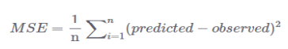

Step 2: Cost reduction. Final goal is to refine the bottlenecks of our neural network in order to lower costs. You can find that if you see our neural network, we can only monitor weights and damage. The remainder is beyond our grasp. Inputs cannot be checked, the output of the dot cannot be controlled and the sigmoid function cannot be regulated. To order to reduce costs, we must take into account the weight and bias values that are the lowest value for costs to the feature. The lower the rate, the more correct predictions. This is a problem of optimization where the function must be minimized.

We can use the decent gradient Algorithm (GDA) to find the minimum of a function. The decent gradient algorithm can be described as follows mathematically:
Essentially measure the weight and partiality component of the partial cost function, and subtract the effect from the existing weight values to produce the new weight values. At any given point the derivative of a function gives us its pitch. In order to determine whether expenses, if the weight value, increases or decreases, the function derivatives can be considered at this particular weight value.

The derivative produces a positive value, which is then removed from the current value, if the cost declines with the weight gain. In the other side, if the expense decreases with a weight reduction, it will recover a negative number and add it to the new weight, because the negative with the negative would become positive.

Equation 1 shows an image of the alpha, which is compounded by the gradient. This is known as the speed of learning. How quickly our algorithm learns determines the rate of learning. For all weights and prejudices, before the costs are reduced to the optimum point, we need to repeat the performance of Equation 1. In certain words, before we have some bias and weight values the cost function returns a value that resembles zero, we have to begin implementing equation 1.

Part B
Code and Output:

Observation & Learning:

Conclusion:

